joe bayliss name images:

white text on black background

grey text on white background

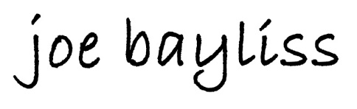 black text on white background

